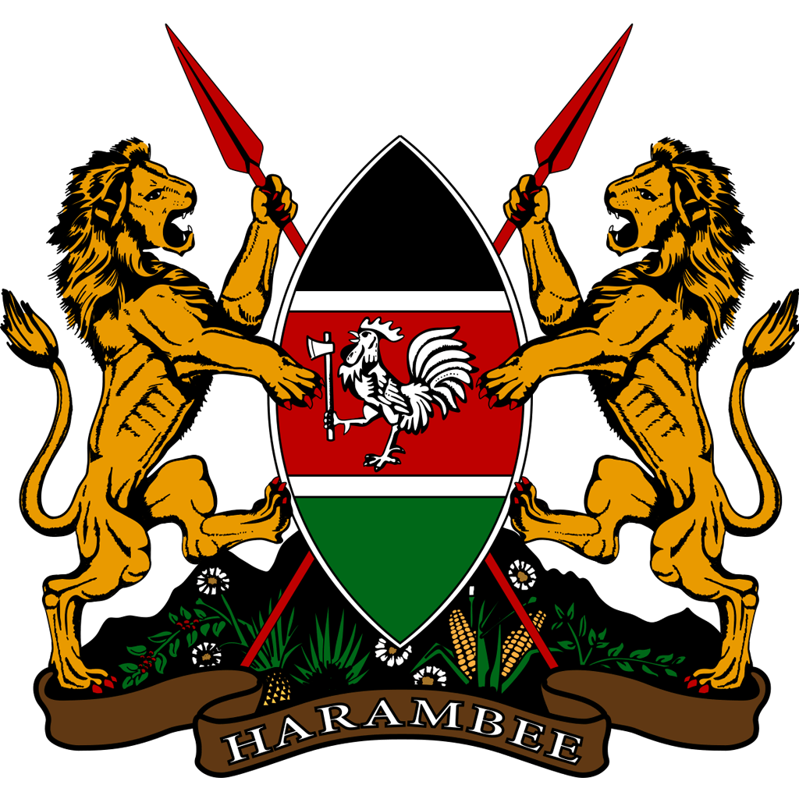
MINISTRY OF HEALTH

